EADS NA Defense Test & Services

Software Design Document

Third Echelon Test Set (TETS)

DEFCOT&S-3562-SDD-000
Version – 0
12/05/2005

This document and the information contained herein are proprietary to EADS NA Defense and may not be disclosed in whole or in part to any parties without the expressed written consent of EADS NA Defense.

PAWS is a registered trademark of the TYX Corporation.

© EADS NA Defense Test & Services
1222 Lucas Ave. Suite 200
St. Louis MO 63103
phone (314) 727 1337
fax (314) 727 6750

TETS Software Design Document

Version – 0

History of changes
-: Preliminary revision

Table of Contents

1 Identification – TETS 5
1.1 Purpose 5
1.2 Scope 5
1.3 Definitions and Acronyms 5
1.4 References 5
1.5 Decomposition Description 5
1.5.1 Module Decomposition 5
1.5.2 Concurrent Processes 6
1.5.3 Data Decomposition 6
1.5.3.1 ATLAS Verbs 6
1.5.3.2 ATLAS Nouns, and Modifiers 7
1.6 Dependency Description 7
1.6.1 Inter Module Dependencies 7
1.6.2 Inter Process Dependencies 7
1.6.2.1 Prerequisites 7
1.6.2.2 Part of PAWS WCEM Driver Support. 7
1.6.3 Data Dependencies 7
1.7 Interface Description 7
1.7.1 Module Interface 7
1.8 Module Components 7
1.9 The Driver Functions 7
1.9.1.1 Inputs and user Interface 9
1.9.2 Process Interface 10
1.10 Detailed Design 10
1.10.1 Data Design 10
1.10.1.1 Definition 10
1.10.1.2 Pre-Processing 10
1.10.1.3 Measurement 11
1.10.1.4 Post- Processing 11
2 Attachment A: Arb_GenSdd.doc 12
3 Attachment B: Bus_CddiSdd.doc 12
4 Attachment C: Bus_DDC1553Sdd.doc 12
5 Attachment D: Bus_Ethernet_GigabitSdd.doc 12
6 Attachment C: Bus_MicCanSdd.doc 12
7 Attachment D: Bus_RS422Sdd.doc 12
8 Attachment E: Bus_RS485Sdd.doc 12
9 Attachment F: Bus_TcimSdd.doc 12
10 Attachment G: CntrSdd.doc 12
11 Attachment H: DcPsSdd.doc 12
12 Attachment I: DmmSdd.doc 12
13 Attachment J: DsoSdd.doc 12
14 Attachment K: DwgSdd.doc 12
15 Attachment L: FncGenSdd.doc 12
16 Attachment M: Rf_GenSdd.doc 12
17 Attachment N: SyncResSdd.doc 12
18 Attachment O: SWITCH TBD 12

Identification – TETS
This document provides the software configuration item descriptions necessary to control the TETS Test Station.
  - Purpose
The purpose of this document is to provide the detailed software design of the PAWS drivers for the TETS control from ATLAS via the PAWS system utilizing a Common Control Interface (CICL) The following described driver software exists to fulfill the requirements defined in the “Third Echelon Test System (TETS) Software Requirements Specification” document DEFCOT&S-3536-SRS-001:

Scope
The document defines the detailed software design for the PAWS drivers for the TETS. The document will deal with those aspects of software design unique to TETS and to the PAWS interface.

Definitions and Acronyms

ATLAS Abbreviated Test Language for All Systems
Function Specific task within a test
PAWS Professional ATLAS Work Station
Benchmark Grouping of test in a particular order to demonstrate implemented
functionality
VME Bus architecture providing excellent computer backplane
VXI VMEbus extension for instrumentation

References
Industry:

IEEE STD 1016 Software Design Descriptions
IEEE STD 716-1989 IEEE Standard C/ATLAS Test Language.

Project:

MARCORSYSCOM-PD-02-001 Performance Specification For The Third Echelon Test Set (TETS) 1-Dec-03
7992052 Rev 03 – DRAFT General Notes for ATLAS Implementation
30 September 2005
IEEE STD 716-1989 IEEE Standard C/ATLAS Test Language.
ARCSTL-DSG-000 ARC PAWS WCEM Software Development Style Guide

DEFCOT&S-3536-SRS-001 Third Echelon Test System (TETS) Software Requirements Specification

Decomposition Description

Module Decomposition
Each driver will consist of a PAWS Project which will consist of:

- A Microsoft Visual C++ project to build the WCEM
  - WCEM Wizard generated interface files
    - Wrapper.cpp
    - error.cpp
    - key.h
  - Configuration Information
  - Arb.rc
  - resource.h
  - Updated Template File
    - Arb.cpp
  - The programmer generated driver files
- Arb_T.cpp

- A PAWS Developer’s Studio project file for the benchmark Arb.PAW
  - An ATLAS program or programs to test the driver (Benchmark)
- A Device Database static Description

Concurrent Processes
PAWS Test Executive

Data Decomposition

ATLAS Verbs
Each module will reference one or more of the following verb groups.

Sensor verbs:

VERIFY
MEASURE
SETUP
INITIATE
FETCH
CONNECT
DISCONNECT
REMOVE

Timing Sensor verbs:

START WHEN
STOP WHEN

Source verbs:

APPLY
SETUP
CONNECT
DISCONNECT
REMOVE

ATLAS Nouns, and Modifiers
Each module description will contain a detailed description of the verbs, nouns, modifiers, etc. used with the instrument functions controlled.

Dependency Description

Inter Module Dependencies
To be developed as an independent module. References made to the “Switch” module as required by all instrument modules.

Inter Process Dependencies

Prerequisites
Each module will describe any prerequisites.

Part of PAWS WCEM Driver Support.
To be developed as standalone driver callable from the Test Executive.

Data Dependencies
Each module will specify any data dependencies.

Interface Description

Module Interface
All modules interface with the PAWS Run Time System via the normal WCEM feature of the PAWS development system.

Module Components
The file header, constant definition, global/static variable use, will conform to the referenced style guide. At a minimum, the file header will contain the following information:

- File Name
- Revision and Date
- Purpose
- Instrument
- Required Libraries / DLL’s (including Plug&Play)
- ATLAS Subset
- ATLAS Extensions Required
- List of Functions, including required and additional functions
- Revision History

The Driver Functions
The drivers’ functions will be drawn from the required list, as appropriate to the device type. The following list defines some of the standard entry points into the driver file.

Function | Purpose
CDMM(bool sim, int dbglvl, int addr) | This function is used to initialize the instrument, obtain a handle from VISA or other controller software, and establish if the device is in simulation mode and / or debug.
~DMM(void) | This function shuts down the instrument and releases the device handle.
SetupDMM(int fnc) | This function is the entry point for the setup action. The argument is the FNC number from the DeviceDB Static Description.
StatusDMM(void) | This function queries the instrument for status and reports any errors to the RTS via the error handling mechanisms
FetchDMM(int fnc) | This function is responsible for retrieving measured values from the instrument and returns them to the RTS via the fetch API in WCEM or other support libraries
InitiateDMM(int fnc) | This function controls the ATLAS INITIATE actions and is responsible for enabling or triggering a signal
ResetDMM(int fnc) | This function is responsible for resetting the instrument. The argument 0 will be reserved for a RESETALL action and shall reset the instrument regardless of the current state of the device. Arguments > 0 may use a state variable to determine if the device is currently reset.
CloseDMM(int fnc) | This function is responsible for the ATLAS CLOSE verb and shall close any internal relays within the instrument and will enable the output or input to the device.
OpenDMM(int fnc) | This function is responsible for the ATLAS OPEN verb and will disable the output or input of the instrument.

Table 4

Inputs and user Interface
      - Driver inputs are defined in the syntax diagrams above.

Process Interface
General CEM interface overview

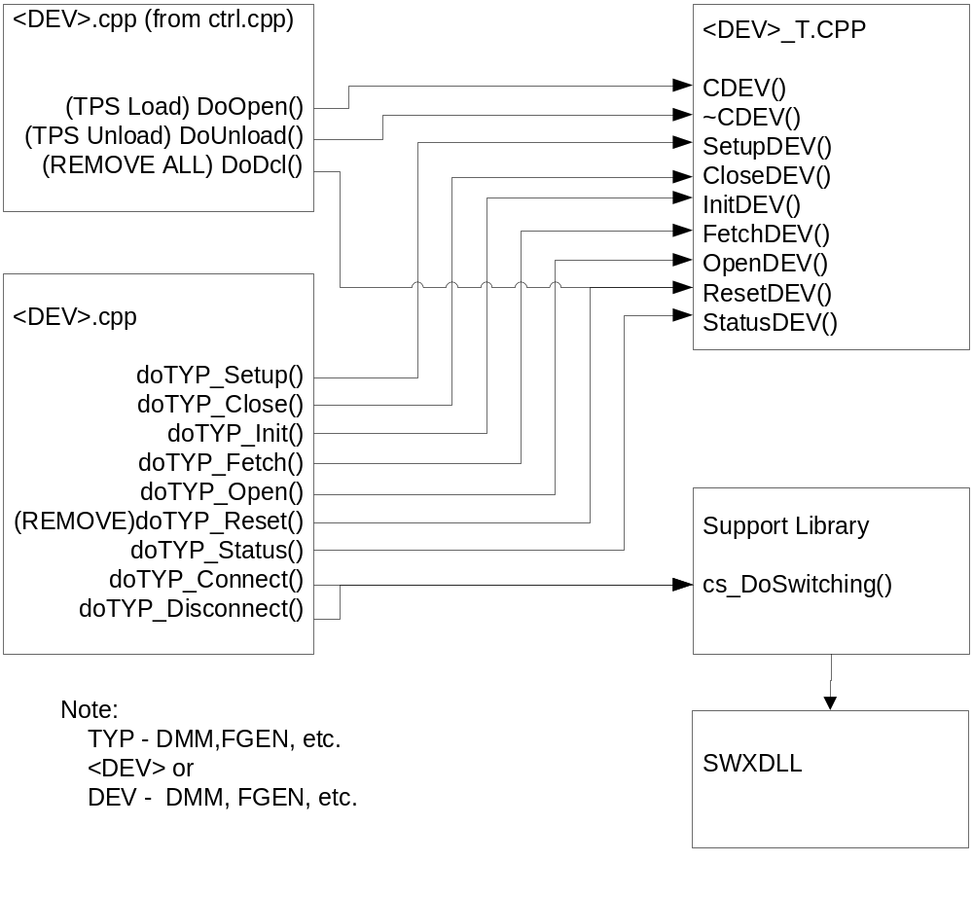

CEM Wizard Relationships

Detailed Design

Data Design

Definition
Each module will describe the driver interface functions as applicable.

Pre-Processing
Each module will describe any pre-processing required.

Measurement
Each module will describe the measurements to be made and dependant parameters.

Post- Processing
Each module will describe any pre-processing required, including error processing.
List of Attachments

Attachment A: Arb_GenSdd.doc

Attachment B: Bus_CddiSdd.doc

Attachment C: Bus_DDC1553Sdd.doc

Attachment D: Bus_Ethernet_GigabitSdd.doc

Attachment C: Bus_MicCanSdd.doc

Attachment D: Bus_RS422Sdd.doc

Attachment E: Bus_RS485Sdd.doc

Attachment F: Bus_TcimSdd.doc

Attachment G: CntrSdd.doc

Attachment H: DcPsSdd.doc

Attachment I: DmmSdd.doc

Attachment J: DsoSdd.doc

Attachment K: DwgSdd.doc

Attachment L: FncGenSdd.doc

Attachment M: Rf_GenSdd.doc

Attachment N: SyncResSdd.doc

Attachment O: SWITCH TBD

